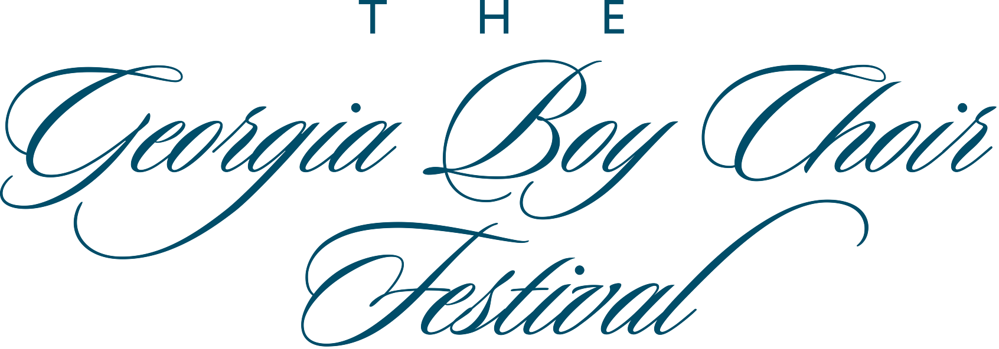

David R. White, Artistic Director and Conductor

Saturday, February 16, 2013

Festival Concert 7:00 pm

Peachtree Road United Methodist Church

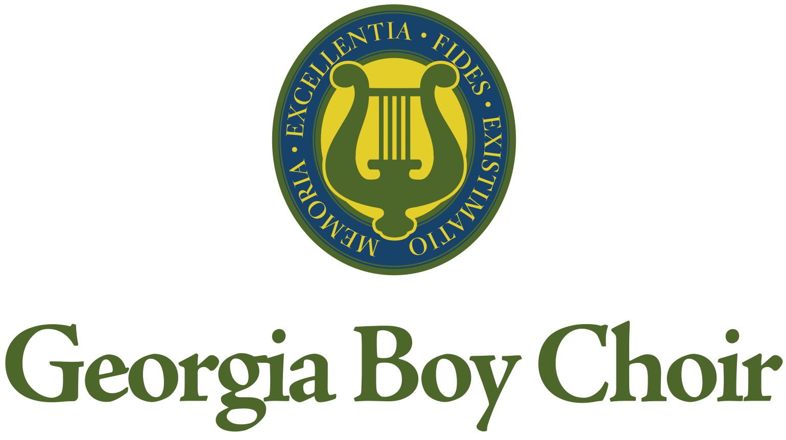
Establishing a Legacy of Excellence

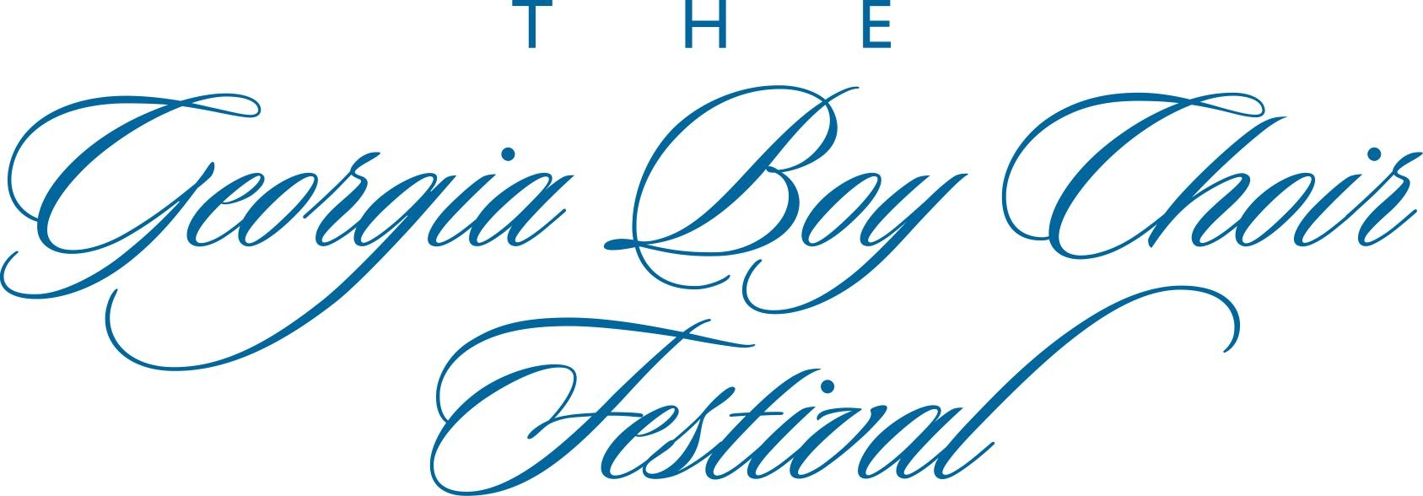

P R O G R A M

Fanfare For a Festival Ron Nelson

All praise! All praise to music! Heaven sent.
The voice that lifts all hearts in perfect melody,
And leaves the soul fulfilled with joy and peace.
All praise! All praise to music! Heaven sent.
In open song!
~ Walter Rodby

Marching to Zion Robert Lowry
arr. John Ferguson

The Audience is invited to sing on the final stanza

Come we that love the Lord, And let our joys be known;
Join in a song with sweet accord, And thus surround the throne. Alleluia.

We’re marching to Zion, Beautiful, beautiful Zion;
We’re marching onward to Zion, The beautiful city of God.

Let those refuse to sing Who never knew our God;
But children of the heavenly King May sing their joys abroad. Alleluia.

Then let our songs abound, And every tear be dry; We’re marching through Emmanuel’s ground
To fairer worlds on high.

We’re marching to Zion, Beautiful, beautiful Zion; We’re marching onward to Zion,
The beautiful city of God.

I Will Arise Traditional American Hymn
arr. Alice Parker and Robert Shaw

I will arise and go to Jesus, He will embrace me in His arms,
In the arms of my dear Savior, Oh! There are ten thousand charms.

Teach me some melodious sonnet Sung by flaming tongues above,
Praise the mount, I’m fixed upon it, Mount of Thy redeeming love.

Come Thou Fount of every blessing, Tune my heart to sing Thy grace,
Streams of mercy never ceasing, Call for songs of loudest praise.

T H E F E S T I V A L C H O I R

************

Domine, Ad Adjuvandum me Festina Il Padre G. B. Martini

Domine, ad adjuvandum me festina.

Gloria Patri et Filio
et Spiritui Sancto;
Sicut erat in principio
et nunc et semper
Et in saecula saeculorum. Amen. Alleluia

Lord my God, make haste to help me.

Glory be to the Father and the Son,
and the Holy Spirit
As it was in the beginning,
is now and ever shall be,
World without end,
Amen. Alleluia.

~ Psalm 70:1

Pilgrims’ Hymn Stephen Paulus

Even before we call on Your name To ask You, O God,
When we seek for the words to glorify You, You hear our prayer;
Unceasing love, O unceasing love, Surpassing all we know.

Glory to the Father, And to the Son, And to the Holy Spirit.

Even with darkness sealing us in, We breathe Your name,
And through all the days that follow so fast, We trust in You;
Endless Your grace, O endless Your grace,
Beyond all mortal dream.

Both now and for ever, And unto ages and ages, Amen.
-- Michael Dennis Browne

Hark, I Hear The Harps Eternal Traditional American Hymn
arr. Alice Parker and Robert Shaw

Hark, I hear the harps eternal Ringing on the solemn shore,
As I near those swollen waters, With their deep and solemn roar.
Hallelujah, praise the Lamb. Glory to the great I AM.
And my soul, though stained with sorrow, Fading as the light of day,
Passes swiftly o’er those waters To the city far away.
Souls have crossed before me, saintly, To that land of perfect rest;
And I hear them singing faintly In the mansions of the blest.

Omnia Sol Z. Randall Stroope

Somewhere far from nowhere, I grew both strong and tall,
Longing to become, but knowing not the path at all.
But the footprints of the winter melted to fields of spring;
One last embrace before I cross the threshold; To Life we sing!

O stay your soul and leave my heart its song,
O stay your hand, the journey may be long.
And when we part and sorrow can’t be sway’d,
Remember when and let your heart be staid.

(Translation):
The sun warms everything, even when I am far away.
Love me faithfully, and know that I am faithful.

Weave the dance and raise the chorus, grieve no more.
Through the strength of Orion find refuge from the shore.
Let courage be your oar, let passion be your sail.
Wisdom and Truth will guide your deep heart’s yearning, through all travail.
~ Z. Randall Stroope

What A Wonderful World G.D. Weiss and Bob Thiele
arr. David R. White

I see trees of green, red roses too, I see them bloom for me and you,
And I think to myself, "What a wonderful world."

I see skies of blue and clouds of white,
The bright blessed day, The dark sacred night,
And I think to myself, "What a wonderful world."

The colors of the rainbow, so pretty in the sky
Are also on the faces of people passing by.
I see friends shaking hands saying, "How do you do!"
They're really saying, "I love you."

I hear babies cry, I watch them grow.
They'll learn much more than I'll ever know,
And I think to myself, "What a wonderful world."

Ride On, King Jesus American Spiritual
arr. Moses Hogan

Ride on, King Jesus; ride on, the conquerin’ King.
No man can hinder thee.
I was but young when I begun. But now my race is almost done. King Jesus rides a milk white horse.
The river of Jordan He did cross.
He’s the King and the Lord. He’s the First and the Last.
He’s the Lord of Lords. Jesus is the Prince of peace.

The Georgia Boy Choir

************

Wade In the Water American Spiritual
arr. Norman Luboff

Wade in the water, God’s a-gonna trouble the water.
See that band all dressed in white, the leader looks like an Israelite.
See that band all dressed in red, it looks like the band that Moses led.
Wade in the water, God’s a-gonna trouble the water.

Non Nobis Domine Patrick Doyle

Non nobis Domine,
Sed nomine tuo da gloriam.

Not unto us, O Lord,
But unto Thy name be glory.
~ Psalm 115

O Thou the Central Orb Charles Wood

O Thou the central orb of righteous love,
Pure beam of the most High,
Eternal Light Of this our wintry world,
Thy radiance bright Awakes new joy in faith,
Hope soars above,
Come quickly come, and let Thy glory shine,
Gilding our darksome heaven with rays Divine.
Thy saints with holy luster round Thee move,
As stars about Thy throne,
Set in the height Of God’s ordaining counsel,
As Thy sight Gives measured grace to each, Thy power to prove. Let Thy bright beams disperse the gloom of sin,
Our nature all shall feel eternal day, In fellowship with Thee, Transforming day to souls erewhile unclean, now pure within. Amen.
~ H.R. Bramley

Dona Nobis Pacem Giulio Caccini

Lord, grant us peace

The Georgia Boy Choir wishes to acknowledge and thank Senior Minister, Rev. Bill Britt, Music Director, Scott Atchison and the rest of the Staff and Congregation of Peachtree Road United Methodist Church for their overwhelming generosity and friendship.

The THIRD Annual

G E O R G I A B O Y C H O I R F E S T I V A L

is scheduled for

February 17 & 18, 2012

Make your plans NOW to attend.

The Georgia Boy Choir

The Apprentice Choir

Jayden Barkley
Evan Bauer
Paul Colker
Tommy DeShong
Bailey Ferrell
Patrick Garner
Will Gittner
Justin Goldman
Sebastjan Hutton
Alok John
Preston Kelly
Joshua Lowther
Ben Martin
Alexander Milburn
Alexander Moore
Hayes Pope
Peyton Portfolio
Taylor Portfolio
Alexander Spiegel
Trip Tatroe
Noah Walton
Michael White
Zachary Woods

The Training Choir

Kaleb Brooks
Luke Cochran
James Cuffee
Adrian Frykman
Jackson Grady
Sean Hatten
Jackson Heydt
Evan Hunter
Komichel Johnson
Demetrice Jones
Grant Maxey
Jeremie Meadows
Alexander Merryman
Emile Moolenaar
Jaylin Murphy
Nicholas Newton
Albert Overett
Tyler Owens
Ethan Rotnem
Cole Roxbury
Teddy Stonebraker
Matthew Sturniolo
Jacob Walton

The Intermediate Choir

Joe Billips
Maxwell Clements
Collin Cruikshank
Jack Dillard
Nate Ellis
Will Hamilton
Maksim Hull
Thomas Jackson
Chosen Jacobs
Ethan McDonnell
Gavin McDonnell
Logan McHugh
Tillman Minter
Charles Simpson
Dillon Tanner
Ethan Terrell
Loren Tsang
Joshua Welch
Tomohisha Yoda

The Concert Choir and Young Men’s Ensemble

Harrison Citron
Garrison Ferrell
Mason Gordon
Patrick James
Abinay John
Andrew Liang
Shawn Lunde
Oak Martin
Keegan McDaniel
Ruben Roy
Walt Semrau
Thomas Stokes
Eric Sturniolo
Dylan Truong
William White
Steven Colker
Sounak Das
Aaron Jones
Marc Laroussini
Evan Mercer
Jake Mercer
Jesse Rhodes
Mac Rubright
Duane White
Michel Vazirani

Artistic Director and Conductor, David R. White has been training boys and young men to sing for more than two decades. In 1994, he founded the Boy Choir of the Carolinas in Greenville, South Carolina. In 1998 he became the Music Director of Florida’s Singing Sons Boychoir in Fort Lauderdale, Florida. From 2001 to 2009, Mr. White was the Artistic Director and Conductor of the Atlanta Boy Choir in Atlanta, Georgia. Under his direction, choirs have participated in numerous festivals throughout the world including the Prague International Choral Festival, the Pacific International Children’s Choir Festival, the Anchorage Choral Festival, the Cultural Olympiad in Greece, the Baltimore Boychoir Festival, the Southeast Festival of Song, and the Choral Olympics in Linz, Austria. He has been a conductor on the faculty at the Interlochen Center for the Arts in Interlochen, Michigan as well as the Csehy Summer School of Music in Philadelphia. Mr. White holds a Bachelor of Music degree in Voice Performance from Georgia College and is active as a lecturer, adjudicator, and conductor for choral and vocal competitions, workshops, and festivals. He currently holds the position of Repertoire and Standards Chair for the Georgia Chapter of the American Choral Directors Association.

Associate Conductor and Organist, Scott Hamilton Atchison currently serves as director of music and organist at Peachtree Road United Methodist Church in Atlanta, Georgia, where he administers a program including nine choirs. Under his leadership, the choirs have performed in some of the most venerable cathedrals and halls around the world. In the United States, the Choir of Peachtree Road has appeared at Carnegie Hall, the National Cathedral in Washington D.C., and the Cathedral of St. John the Divine in New York City. The Peachtree Road Choir has toured internationally for many years. Notably, the choir has appeared at St. Paul’s and Wells Cathedral in the United Kingdom and Notre Dame, Chartres, and Reims Cathedral in France. In 2002, Mr. Atchison began the design and installation of the 106-stop Mander Organ in the church’s new sanctuary. In November of that year, he was the featured soloist in the premiere of the Concerto for Organ, Orchestra and Chorus by renowned composer Stephen Paulus with the Atlanta Symphony Orchestra under the baton of Mr. Robert Spano. The music program at Peachtree Road United Methodist Church includes a full-scale concert series which draws music lovers from across the city. The series includes at least two major choral works each season with members of the Atlanta Symphony Orchestra. Mr. Atchison’s schedule keeps him busy as an organ recitalist and choral clinician across the country. Mr. Atchison received his training in organ performance and choral conducting from Furman University as well as Georgia State University where his teachers included Lindsay Smith and Robert L. Simpson. Professional memberships include the American Guild of Organists, American Choral Directors Association, and the Royal School of Church Music.

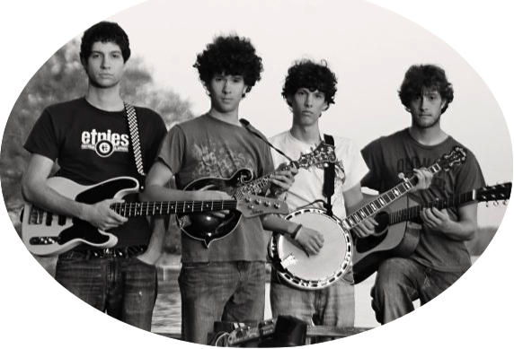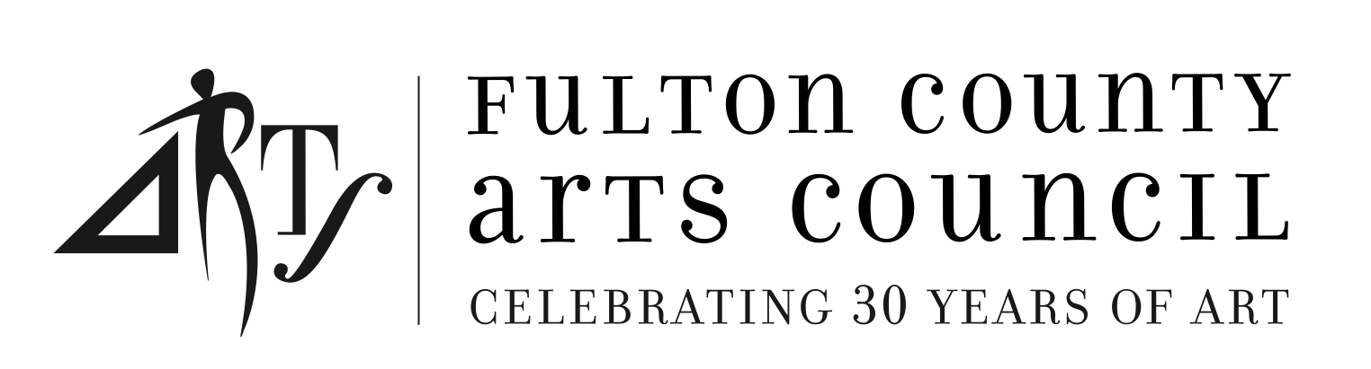

The Bent Strings of Buckhead
